NHS Greater Glasgow and Clyde Adult Blood Glucose and Combined Ketone Meter and Test Strip Formulary 2022-2025
Primary Care and Acute Joint Formulary

Blood Glucose Meter formulary developed by the Diabetes MCN
Updated August 2023

Review date: May 2025
Foreword
The NHS Greater Glasgow & Clyde Blood Glucose and Combined Ketone Meter Test Strip Formulary has been developed to provide practitioners with a selection of preferred meters and test strips for adult patient self-monitoring of blood glucose and ketones.

Practitioners should aim to prescribe a product included in the Formulary and only use a non-formulary product when there is a good clinical reason for doing so. Test strips out with the formulary may only be prescribed on GP10 if there is a clear clinical need for a non-formulary choice to be made.

It is recognised that variation in product choice may occur in specialist areas. In such circumstances providing primary care clinicians with the rational for an alternative choice to the preferred meters will avoid any delay in the supply of strips and lancets. For example, Wavesense Jazz is often chosen by diabetes centres for people with gestational diabetes mellitus.

Supplies of the preferred meters and starter packs can be obtained by contacting the local representatives as listed in the reference table. Patients should be dissuaded from purchasing a meter themselves without prior discussion with their healthcare professional as strips and lancets will not automatically be supplied.

The Blood Glucose and Combined Ketone Meter Formulary follows the same structure as the NHSGGC Formulary with choices being subdivided into two categories: Preferred List – these represent the first line choices for use by the majority of patients with type 1 and type 2 diabetes requiring a meter, Total Formulary List– contains a specialist meters.

Continuous Glucose Monitoring

NHS GGC policy on the use of CGM can be found here:
Real-time continuous glucose monitoring (eg Dexcom One) and intermittently scanned (flash) glucose monitoring systems (eg Libre 2) are intended to be used as an alternative to routine finger-prick blood glucose monitoring for people with diabetes who intensively manage their condition with multiple daily insulin injections or insulin pump therapy and are actively engaged in the management of their diabetes.

Finger-prick blood glucose monitoring, however is still indicated for this cohort in the following circumstances:
- During times of rapidly changing glucose levels –interstitial fluid glucose levels may not accurately reflect blood glucose levels during these times
- If the CGM monitoring system indicates hypoglycaemia or impending hypoglycaemia
- When symptoms experienced by the patient do not match the CGM monitoring system readings.
Only specialist diabetes teams can initiate patients on Continuous Glucose Monitoring.

NHS GG&C Blood Glucose and Combined Ketone Meters & Strip Formulary
Specific meter & test strip information can be found in the attached Reference Table
Preferred List Blood Glucose Meters & Strips if ketone testing not required
Preferred blood glucose meters for adult patients with type 1 and type 2 diabetes.
- Contour Plus Blue Easy to read & use. Colour indicator shows if BG is within/above/below target range. Long test strip expiry for infrequent testing. Second chance sampling with same strip
- Glucofix Tech GK (replaces Glucofix Tech August 2023) Easy to read & use device. Updated with buttons at the front for ease of use. It uses inbuilt near field communication (NFC) to allow electronic transfer of results to Android & iOS devices.

Blood Glucose & Ketone Monitoring in patients with type 1 diabetes
- Glucomen Areo GK (replaces Glucomen Areo August 2023) Easy to read & use device. Updated with buttons at the front for ease of use. Combining ketone and blood glucose testing in the one meter with inbuilt NFC technology to transfer information to Android & iOS devices.
- Glucofix Tech GK (replaces Glucofix Tech August 2023) Easy to read & use device. Updated with buttons at the front for ease of use. It uses inbuilt near field communication (NFC) to allow electronic transfer of results to Android & iOS devices.
- CareSens Dual CareSens Dual is an easy to read device combining blood glucose & ketone testing in one meter. The addition of BluetoothTM technology enables easy transfer of information to both Android and Apple[iOS] devices.

Total Formulary Blood Glucose Meters & Strips
Second line if ketone testing not required
Palmdoc 2 has a large screen with speaking function for those with poor vision. It can link via diasend and is multilingual with Arabic, Bengali, Polish, Urdu and English. It can store 900 results; Palmdoc test strips (50 pk) £5.90 (DT Oct 2023)

The Formulary recommendations apply across primary and secondary care.
Supplies of the preferred meters and starter packs can be obtained by contacting the local representatives as listed in the reference table.

Glucofix Tech GK and Glucomen Areo GK:
marketingsupport@menarinidiag.co.uk Tracey.gill@menarinidiag.co.uk agreen@menarinidiag.com orders@menarinidiag.co.uk
Contour Plus Blue: Susanne Caw, 07717 420297, [Susanne.caw@ascensia.com]
Caresens Dual: Amalia Rokofyllou, 07880 195488, [amalia.rokofyllou@spirit-healthcare.co.uk ]
Palmdoc 2: Helen Smithson 07377 353732 [helen@palmdoc.co.uk] 0800 994 9995

Patients should be dissuaded from purchasing a meter themselves without prior discussion with their healthcare professional as strips and lancets will not automatically be supplied.

 | 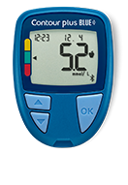  Preferred List Formulary Meter | Preferred List Formulary Meter | 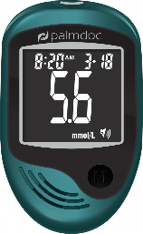  Second line
Meter | Contour Plus Blue | GlucoFix Tech GK | Palmdoc2
 |  | 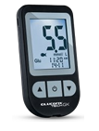
Features | Smart Colour range coding  Second chance sampling | Large bright display, meal markers | Speaking Function: English, Bengali, Polish, Urdu & Arabic Large screen
Memory capacity | 800 tests | 730 BG tests | 900 tests
Glucose Strip Name | Contour Plus Test Strips | Glucofix Tech Sensor | Palmdoc Test Strips
Drug Tariff price | £5.95 | £5.95 | £5.90
Test Strips | Vial of 50 | Vial 50 | 2x25 Vials
Strip expiry date | 24 months | 12 months | 6 months
Sample size | 0.6 µL | 0.5 µL | 0.7 µL
Time for results | 5 secs | 5secs | 5secs
Range | 0.6 mmol/L – 33.3 mmol/L | 1.1 - 33.3 mmol/L | 1.1 - 33.3 mmol/L
Haematocrit | 0% - 70% | 10 - 70% | 35-50%
Enzyme | Glucose Dehydronase | Glucose Oxidase | GDH – FAD
Wireless connectivity | Bluetooth | NFC or USB cable | USB data output
App name | Contour Diabetes App | Glucolog Lite
Replacement batteries | Two 3.0V Lithium Batteries (CR2032) | Two 3.0V Lithium Batteries (CR2032) | Two 1.5v AAA batteries
Website | www.diabetes.ascensia.co.uk | www.glucomenday.com | www.palmdoc.co.uk
Connectivity to Diasend | Yes | Yes | Yes
Company details | Ascensia Diabetes Care | A.Menarini Diagnostics | Palmdoc
Customer Service | Ascensia Diabetes Care Support line: 0345 600 6030  Email:  diabetessupport@ascensia.com | 0800 243 667  0118 9444128  Email customersupport@menarinidiag.co.uk | 0800 994 9995.  Email  hello@palmdoc.co.uk

 | Combined Meter Preferred List Formulary | Combined Meter  Preferred List Formulary | Combined Meter  Preferred List Formulary
 | CareSens Dual | GlucoFix Tech GK | Glucomen Areo GK
 | 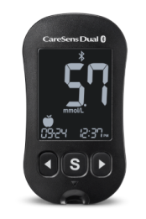 |  | 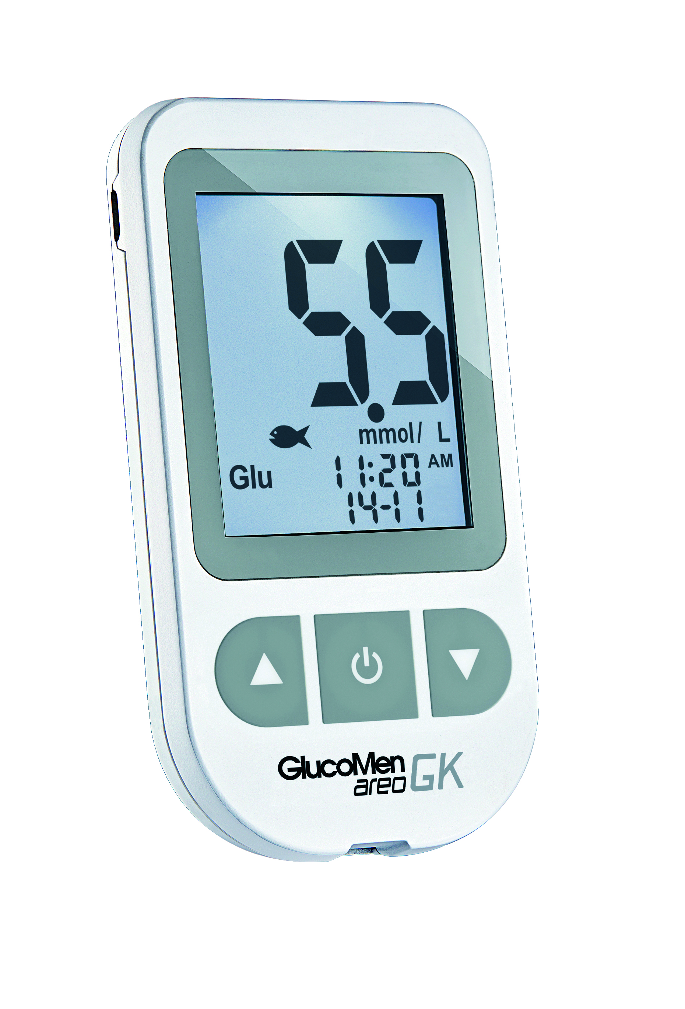
Memory capacity | 1000 | Large bright display, meal markers | 730blood glucose  100 ketone test
Glucose Strips name | CareSens Pro | Glucofix Tech Sensor | Glucomen Areo Sensor
Drug Tariff price  (May 2022) | £9.95 | £5.95 | £7.25
Test Strips | One vial of 50 | Vial 50 | One vial of 50 strips
Strip expiry date | 12 months from opening | 12 months from opening | 12 months from opening
Sample size | 0.4 µL | 0.5 µL | 0.5 µL
Time for results | 5 sec | 5 secs | 5 sec
Range | 1.1-33.3 mmol/L | 1.1 - 33.3 mmol/L | 1.1-33.3 mmol/L
Haematocrit | 15-65% | 10 - 70% | 10-70%
Enzyme | GDH – FAD | Glucose Oxidase | Glucose Oxidase
Replacement batteries | Two 3V CR2032 Lithium Battery | Two 3.0V Lithium Batteries (CR2032) | Two 3V CR2032 Lithium Battery
Website | http://spirit-healthcare.co.uk | www.glucomenday.com | www.glucomenday.com
Connectivity to Diasend | yes | yes | yes
Company details | Spirit Healthcare | Menarini Diagnostics | A.Menarini Diagnostics
Customer Service | 0800 881 5423 | Yes | 0800 243 667
Working hours | 24 hours | Mon- Fri - 8.30-5.30 | Mon- Fri - 8.30-5.30
Wireless connectivity | Bluetooth | NFC or USBcable | NFC or USBcable
App name | SmartLog | Glucalog Lite/ Mobile | Glucalog Lite/ Mobile
Carb Counting App | Balansio | RapidCalc | RapidCalc
 | Ketone | Ketone | Ketone
Blood sample size | 0.5 | 0.8 | 0.8
Ketone Strips name | KetoSens | Glucofix Tech ß-Ketone Sensors | Glucomen Areo Ketone Sensor
Shelf life strips | Expiry date on pack Foil Wrapped | Expiry date on pack Foil Wrapped | Expiry date on pack Foil Wrapped
DT Ketone Strip Price (10) | £9.95 | £9.95 | £9.95
Measurement time | 8 sec | 8 sec | 8 sec
Additional Information
Training
Most meters have the same basic functions and the process to obtain a blood glucose and/ or ketone reading is similar. However it is important that all patients are trained on how to use their meter and know:
- the purpose of testing
- how to interpret the blood glucose results and what action to take
- how often and when to test
- how to use the meter and the lancing device to achieve an accurate result
- when to seek advice from their healthcare professional
NICE recommend that patients with type 1 & type 2 diabetes who are self-monitoring their blood glucose levels, have a structured assessment at least annually to include self monitoring skills. In addition to this the assessment should take account on the impact on the person’s quality of life & the continued benefit of monitoring.

Good Practice in Self Testing & Safe Storage of Blood Glucose and Ketone Testing Strips - Information for Patients
Specific information is included in product leaflets for meters & strips.
SELF TESTING
- Ensure hands are washed with soap and thoroughly dried (with a clean towel) prior to testing. Contaminants on the skin or excess moisture can affect the accuracy of the reading.
- Ensure sufficient blood sample size is applied to the test strip. Do not add more blood after the first drop has been applied.
- Apply fresh blood drop to test strip immediately after blood drop obtained. Not testing promptly can lead to evaporation of blood drop which can affect accuracy of the reading.
- Do not test with a smeared or spread blood drop as this can introduce contaminants. Also, do not wipe or smear the blood drop onto the test strip, simply touch the test strip and blood drop together without excess pressure.
STORAGE
- Store strips in accordance with manufacturer’s instructions. Heat, cold, humidity and moisture can all affect how the strips work which in turn affects the accuracy of the reading.
- Keep strips in their original sealed container only. Ensure container lid is closed properly after each use.
- Check expiry dates of test strips and control solutions. Do not use if out of date. Most strip packaging allows the opening or expiry date once opened to be written on the label
- Store the meter and test strips at room temperature. Keep away from direct sunlight & heat. Do not freeze.
- Do not leave test strips in vehicles for extended periods of time as they are subject to temperature extremes.
- Do not bend, cut or alter test strip in any way.

A Control Solution, available free from meter companies, contains a known amount of glucose and is used to ensure the meter and strips are working correctly. It is advised to routinely use the control solution to test the meter and if there are situations where the blood glucose test results are not as expected.

