NHS Greater Glasgow and Clyde Health Board  REQUEST FOR A NON-FORMULARY (NF) MEDICINE | 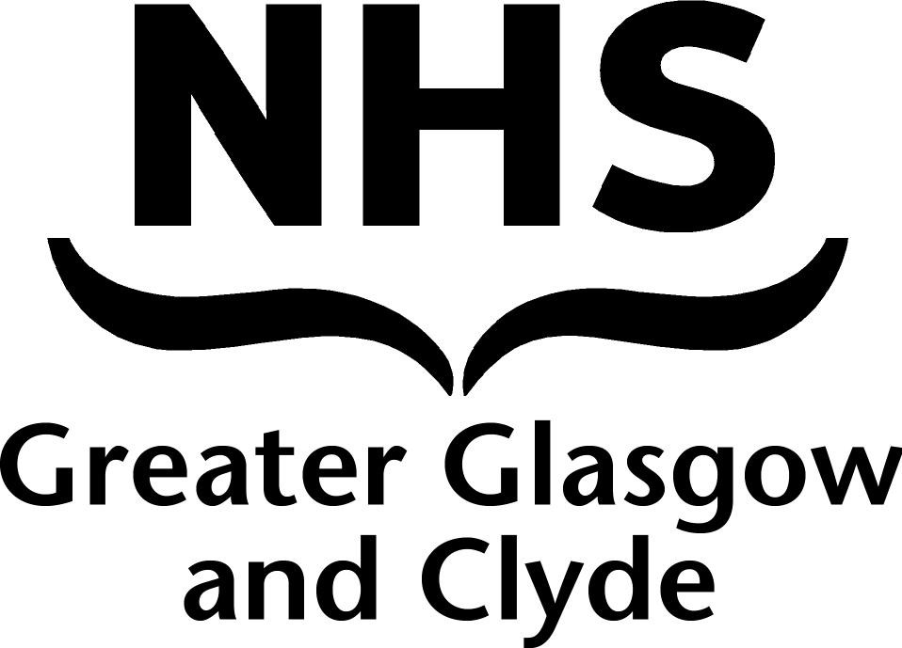

This form is to be completed by GPs either wishing to commence a non-Formulary or non-SMC accepted medicine for a patient, or for those GPs who have received a request from another clinician (e.g. local consultant) to initiate such a medicine. This form does not overrule the clinician’s independence to prescribe whatever he/she sees as being the most appropriate treatment for an individual patient.

A FORM ONLY NEEDS COMPLETING AT INITIATION FOR THOSE MEDICINES INCLUDED ON THE HIGHLIGHTED NON-FORMULARY MEDICINES LIST

Section 1: GP PRACTICE and patient details

Please use practice stamp here |  | Patient details (insert CHI Number only):

Section 2: clinician requesting medicine

Medicine requested:
(Include indication if known)
Who is requesting the medicine?  (please tick) |  | I am requesting the medicine myself: |  | Another clinician has requested I initiate this treatment for this patient:
If another clinician has asked you to initiate this treatment, please provide details of them below
Clinicians Name:
(print clearly)
Specialty:
(e.g. consultant cardiologist)
Contact details:
(Hospital, address, contact number etc if known)

Section 3: other relevant information

Please provide any other information which may be useful in determining whether this treatment is appropriate or not in the space below (such as details of previous treatments tried for this condition)

Section 4: signature and date

Signature:  Person completing the form |  | Date: | / /

This form should be completed and sent to your local CH(C)P Office:

If you are unsure of the details, contact the Central Prescribing Team on (0141) 201 5157 for advice

